Identify Problems

The first problem was the voltage the motors used in the pick and place machine, we were unable find an H bridge capable of supplying 75 volts.

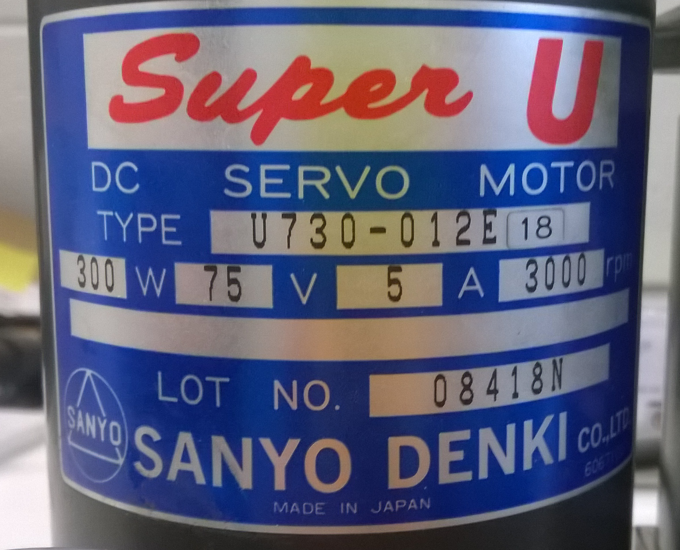

We were given the choice of sourcing a lower voltage 300W motor, looking on the internet we found this type of motor is very common motor and only at 75 volts.

The X and Y motors are of different sizes as one motor moves more weight than the other so we decided to build an H bridge capable of being interchanged that could drive either motor.

